DELPHI Simulated Operating Characteristics of Phase 1 Dose Escalation Designs

*Report Date and Time: 2021-02-02 21:36:38*

*Software:* DELPHI app version XXX available at: <https://bengarski.shinyapps.io/DELPHI/>

**Objective:**

To evaluate the operating characteristics of the following dose escalation designs: <*design*> **3+3, CRM, and TARGET-CRM.**

**Methods:**

Trial operating characteristics are averaged over *<number.trials>* **100** simulated trials. Simulated trials have *<length(true.tox)>* **4** dose levels labelled *<dose labels>* (**-1, 1, 2, 3**), starting on dose level *<start.level>* **1**, and assuming true toxicity probabilities of <*true.tox*> (**0.05,0.12,0.20,0.30**). The target toxicity probability is <*target.tox*> **0.2**. One patient arrives every <*arrival.rate*> **15** days on average. The DLT observation period is <*cycle.length*> **28** days.

<*include the following text only if TARGET-CRM and/or CRM is selected*>

For the TARGET-CRM and/or CRM design, the prior toxicity probabilities per dose level are <*prior*> (**0.05,0.12,0.20,0.30**). The cohort size is <*cohort.size*> **3** and the maximum sample size <*max.N*> is **18**. Patients belong to one of two cohorts: Cohort A or Cohort B. Patients with pre-specified characteristics (e.g. tumor type, tumor mutation) belong to Cohort B; all other patients belong to Cohort A. The TARGET-CRM design allows enrollment of Cohort B patients at one dose level below the current dose during the DLT observation period of the current cohort of patients. The proportion of patients from Cohort B is <*prop.B*> **0.1**.

Simulated trials using the TARGET-CRM and/or CRM designs are required to have a minimum enrollment of <*min.cohortB*> **0** Cohort B patients.

**Results:**

*[Template for TWO OR MORE designs]*

***Accuracy:***For each dose level, **Figure 1** presents the proportion of simulated trials that a given dose level was selected as the true MTD. The <*select design with highest PCS*> **TARGET-CRM** design has greatest probability of selecting the true MTD (dose level <*true.MTD*> **4**). The proportion of correct selection (PCS) of the MTD for the TARGET-CRM design is <*PCS*> **0.5**. The PCS for the 3+3 design is <*PCS*> **0.318**.

***Safety:* Figure 2** presents the proportion of patients experiencing a DLT for each dose level.

The proportion of patients experiencing a DLT for the 3+3 design is <*obs.tox.overall*> **0.173**, which is **lower / greater** than the target toxicity probability of <target.tox> **0.2**. The proportion of patients experiencing a DLT for the TARGET-CRM design is <*obs.tox.overall*> **0.138**, which is **lower / greater** than the target toxicity probability of <target.tox> **0.2**.

**Patient allocation: Figure 3** presents the proportion of patients assigned to each dose level. The <*select design with the highest patient allocation for the true.MTD in patient.allocation.table*> **TARGET-CRM** design has the greatest probability of assigning patients at the true MTD (dose level <*true.tox*> **4**). The proportion of patients assigned to the true MTD for the TARGET-CRM design is <*patient.allocation.table*> **0.50**. The proportion of patients assigned to the true MTD for the 3+3 design is <*patient.allocation.table*> **0.45**.

**Study duration: Figure 4** presents the mean (+/- standard deviation) study duration in days for each design. The <*select design with shortest mean.duration*> **TARGET-CRM** design has the shortest mean study duration. The mean study duration for the 3+3 design is <*mean.duration*> **608.54** days (standard deviation [SD] <*sd.duration*> = **31.21**). The mean study duration for the TARGET-CRM design is <*mean.duration*> **588.89** days (<*sd.duration*> SD=**135.85**).

**Table 1** presents a summary of the operating characteristics for each design.

**Sample size:** The mean total sample size for the 3+3 design is <*mean.obs.N*> **15.36** <*min.obs.N; max.obs.N*> (range=**9-21**).The mean total sample size for the TARGET-CRM design is <*mean.obs.N*> **18** <*min.obs.N; max.obs.N*>(range=**18-18**).

**Enrollment of Cohort B patients (TARGET-CRM only):** The proportion of patients in the population belonging to Cohort B is <*prop.B*> **0.2**. The mean number of Cohort B patients enrolled during the DLT observation period is <*mean.cohortB*> **0.3** (<*sd.cohortB*> SD=**0.541**).

*[Template for ONE design]*

***Accuracy:***For each dose level, Figure 1 presents the proportion of simulated trials that a given dose level was selected as the true MTD. The proportion of correct selection (PCS) of the MTD for the <design> **TARGET-CRM** design is <*PCS*> **0.5**.

***Safety:*** Figure 2 presents the proportion of patients experiencing a DLT for each dose level. The proportion of patients experiencing a DLT for the <*design*> **TARGET-CRM** design is <*obs.tox.overall*> **0.138**, which is **lower / greater** than the target toxicity probability of <*target.tox*> **0.2**.

**Patient allocation:** Figure 3 presents the proportion of patients assigned to each dose level. The proportion of patients assigned to the true MTD (dose level <*true.tox*> **4**) for the <design> **TARGET-CRM** design is <*patient.allocation.table*> **0.50**.

**Study duration: Figure 4** presents the mean (+/- standard deviation) study duration in days for each design. The mean study duration for the <*design*> **TARGET-CRM** design is 608.54 days (standard deviation [SD] = 31.21).

**Table 1** presents a summary of the operating characteristics for each design.

**Sample size:** The mean total sample size for the <*design*> **TARGET-CRM** design is <*mean.obs.N*> **18** <*min.obs.N; max.obs.N*> (range=**18-18**).

<*Include only if TARGET-CRM design is selected*> **Enrollment of Cohort B patients:** The proportion of patients in the population belonging to Cohort B is <*prop.B*> **0.2**. The mean number of Cohort B patients enrolled during the DLT observation period is <*mean.cohortB*> **0.3** (<*sd.cohortB*> SD=**0.541**)

# Figures

**Figure 1**: Proportion of simulated trials selecting each dose level as the true MTD. The true MTD is highlighted with a dark outline.

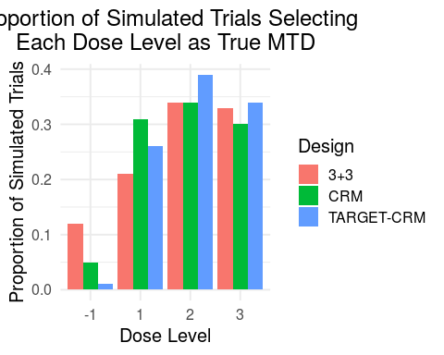

**Figure 2**: Proportion of patients experiencing a DLT per dose level. The target toxicity probability is denoted by the horizontal dashed line. The true MTD is highlighted with a dark outline.

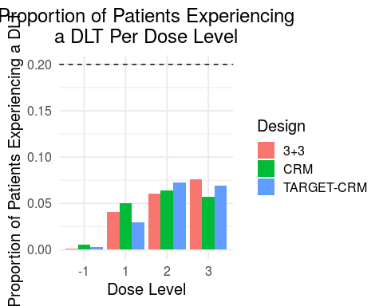

**Figure 3**: Proportion of simulated trials selecting each dose level as the true MTD. The true MTD is highlighted with a dark outline.

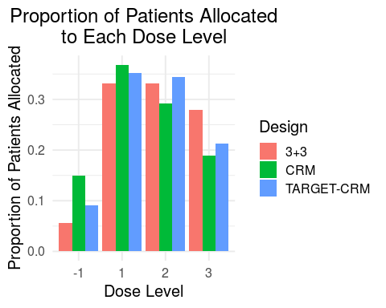

**Figure 4**: The mean (+/- 1 standard deviation [SD]) study duration in days.

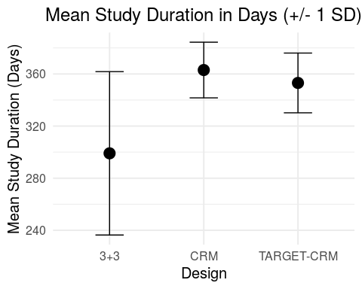

**Table 1:** Summary of operating characteristics for the selected designs.

|  |  |  |  |
| --- | --- | --- | --- |
| Operating Characteristic | 3+3 | TARGET-CRM | CRM |
| Proportion of correct selection (PCS) | 0.340 | 0.390 | 0.340 |
| True MTD | 3.000 | 3.000 | 3.000 |
| Proportion of trials selecting dose 1 as true MTD | 0.120 | 0.010 | 0.050 |
| Proportion of trials selecting dose 2 as true MTD | 0.210 | 0.260 | 0.310 |
| Proportion of trials selecting dose 3 as true MTD | 0.340 | 0.390 | 0.340 |
| Proportion of trials selecting dose 4 as true MTD | 0.330 | 0.340 | 0.300 |
| Proportion of patients experiencing a DLT overall | 0.179 | 0.174 | 0.176 |
| Proportion of patients experiencing a DLT at dose 1 | 0.002 | 0.003 | 0.005 |
| Proportion of patients experiencing a DLT at dose 2 | 0.041 | 0.030 | 0.050 |
| Proportion of patients experiencing a DLT at dose 3 | 0.060 | 0.073 | 0.064 |
| Proportion of patients experiencing a DLT at dose 4 | 0.076 | 0.069 | 0.057 |
| Mean total sample size per trial | 12.750 | 18.440 | 18.660 |
| Minimum total sample size per trial | 9.000 | 18.000 | 18.000 |
| Maximum total sample size per trial | 18.000 | 20.000 | 20.000 |
| Proportion of patients enrolled at dose 1 | 0.056 | 0.092 | 0.150 |
| Proportion of patients enrolled at dose 2 | 0.332 | 0.352 | 0.368 |
| Proportion of patients enrolled at dose 3 | 0.332 | 0.344 | 0.292 |
| Proportion of patients enrolled at dose 4 | 0.280 | 0.212 | 0.190 |
| Mean study duration in days | 299.080 | 353.122 | 363.020 |
| Standard deviation of study duration in days | 62.721 | 22.936 | 21.369 |
| Mean # of cohort B patients enrolled during DLT observation period (TARGET-CRM only) | NA | 0.540 | 0.000 |
| Standard deviation of # of cohort B patients enrolled during DLT observation period (TARGET-CRM only) | NA | 0.731 | 0.000 |